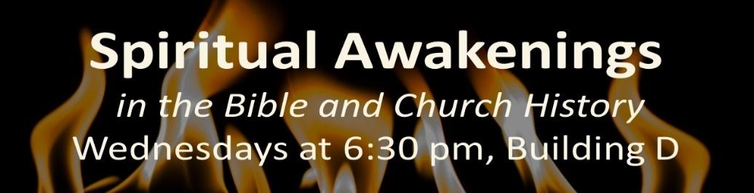
Class 9, February 28
God shaped the world using Spiritual Awakenings. A study of awakenings (1) restores our faith, (2) gives us hope in the future, and (3) teaches us to seek God. We are desperately in need of a spiritual awakening today!
The Ignition of the Church at Pentecost
Prior to the Advent of the Holy Spirit, the disciples were in the Upper Room behind locked doors for fear of the Jews. After…they were on the streets evangelizing the lost. - (Firefall, McDow and Reid, page 86)
The crowds that went out to John and followed Jesus were shrunk to just more than a hundred disciples who had stayed in Jerusalem after the Resurrection. Notably, they prayed together, listened to the Apostles’ teaching, and waited on Jesus to send the Holy Spirit. He came on Pentecost, 50 days after Passover.
In the Old Testament, a very few had had the Spirit, and usually just for a time. But God had promised more: see Joel 2:28:
And afterward, I will pour out my Spirit on all people. Your sons and daughters will prophesy, your old men will dream dreams, your young men will see visions.
The believers spilled out into the city, proclaiming the Good News about Jesus, but in the heart languages of the many Jewish travelers there for the holiday. Peter preached the first post-Resurrection sermon, proclaiming to all what God had done.
The results were many conversions, expressed in baptism, and the beginnings of church life, with the newly constituted church praying together, worshiping through teaching and the ordinances, and loving each other in a care-giving shared life, and loving outsiders with their actions and the Good News.
Lessons from Pentecost
- Spiritual awakenings are God’s initiative.
- Spiritual awakenings are transformative for faithful believers, as well as converts.
- Prayer leads to Spirit working, leads to preaching, leads to conversion.
The Global Awakening, Pt. II, 1904-10
When God desires to do a fresh work, He sets His people to praying.
Mathew Henry
Recall: Welsh revival started in prayer, with conversion, singing and renewed commitment among young people.
- Movement to the United States:
  - Communication with Welsh-Americans inspired prayer, revival.
  - Urban e_______________. Inter-denominational planning, cooperation and prayer.
  - Revival at colleges: Baylor, Asbury and others experienced revival early in the awakening.
  - M___________________ investment; the precursor of NAMB was founded to assist with evangelism in the US. Gideons and YMCA, Biola as well. Many missionaries were called and sent. .
- Charismatic and Pentecostal Christianity
  - H_____________ movement in Methodism had an emphasis on conversion, morphed into a belief in a second baptism by the Holy Spirit, demonstrated by glossolalia.
  - First in Topeka, then Houston and Asuza Street in Los Angeles, charged revivals with extensive reports of tongues, healing, and other sign gifts.
  - There is a spectrum in Christianity between the propositional and the experiential; a ___________________is to be sought.
- Global A___________: from the UK, US, revival spread through new missions and existing mission work to touch Europe, South Africa, West Africa, Indonesia, India and Korea.
- Observations and Lessons - revival begins with prayer, and often confession. Institutions should not stand in the way, but are a natural result of movements which should be carried forward.

