Class 4, Wednesday, December 13
‘Holiday’ is short for ‘holy day.’ In the Old Testament, the family was the primary venue to pass on the faith, and the 70 ‘holy days’ (feasts, celebrations, and Sabbaths) were a primary tool to do so. We need to use a more limited number of holidays to do the same!
Christmas – The Historical Truth of The Christmas Story
Important Truth: Jesus’ birth is history. Children, teens, and adults are so immersed in fiction—TV, movies, gaming, etc.—that we must emphasize history. The Bible gives historical details that allow us to confirm with other sources from history, science, and archaeology.
Examples of Historical Truth from the Bible
#1 – Luke’s intro in 1:1-4 is the statement of a careful historian: “Many have undertaken to draw up an account of the things that have been fulfilled among us, just as they were handed down to us by those who from the first were eyewitnesses and servants of the word. With this in mind, since I myself have carefully investigated everything from the beginning, I too decided to write an orderly account for you, most excellent Theophilus, so that you may know the certainty of the things you have been taught.”
#2 – Luke immediately gives names and places in 1:5: “In the time of Herod king of Judea . . .” Herod is well chronicled in history. The Biblical account is in perfect agreement with his character.
#3 – Luke puts the story in broader “Empire Wide” context in 2:1-2: In those days Caesar Augustus issued a decree that a census should be taken of the entire Roman world. This was the first census that took place while Quirinius was governor of Syria.
Caesar Augustus was the first and one of the most successful Roman Emperors and is extremely well known in history. He ruled for 45 years until his death in 14 AD.
Quirinius (or Cyrenius) was also the well-known general and then governor of Syria—which included parts of Judea at times.
The Census was used both for counting and for taxation.
It is hard to reconcile data from Luke, Matthew, and secular sources for exact dates, but it appears that Jesus was born about 4 BC. The point is that there is historically verifiable information.
#4 – Matthew’s Account of a Star. Matthew’s reference is too vague to give verifiable information, though it is intriguing! Was it a converging of planets at about that time? A miraculous sign?
#5 – Historical/Archaeology Evidence: There is an abundance of evidence for the places mentioned in the birth story of Jesus and for Jesus himself. Nazareth (doubted for years) has now been studied archaeologically. Josephus (a Jewish/Roman historian who was not a Christian) mentions Jesus. Tacitus (a first century Roman historian) mentions Jesus and his death by crucifixion.
Passing on the Faith (Review & New)
- Include Jesus in the gift-giving.
- Have a child read the Christmas Story.
- Tell the story using the characters in your Nativity Set.
- Participate in your church’s Christmas events.
- Do a walk/ drive and have a senior member tell their story.
- Have daily prayer asking God to make Christmas memorable.
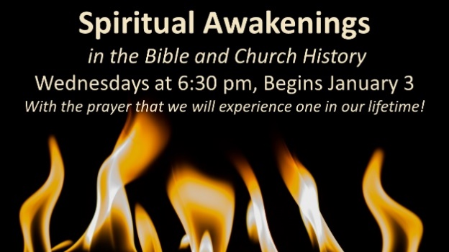
- Include a family service or mission project.
- Let your family know that all the information points to a REAL Jesus!

